Name: _____________________________________________ Block:________
Areas of Polygons

Perimeter, Circumference, and Area
Warm-Up:
Find the length of the hypotenuse in each right triangle. If the length is not a whole number, give the answer in simplest radical form.

Objectives: 1.

2.

Class Notes:

Perimeter
Area

Perimeter, Circumference, and Area
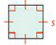  Square  P =  A = | Triangle  P =  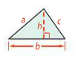  A =
Rectangle  P =  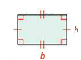  A = | Circle  C =  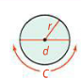  A =

Find the circumference of the circle in terms of $π$. What is the circumference of the circle to the nearest tenth?

What is the circumference of a circle with a radius of 12 m in terms of $π$?

What is the circumference of a circle with a diameter of 12 m to the nearest tenth?

What is the perimeter of $∆EFG$?
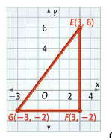
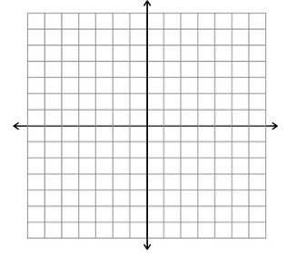

Graph quadrilateral JKLM with vertices J(-3, -3), K(1, -3), L(1, 4), and M(-3, 1). What is the perimeter of JKLM?

What is the area of circle K in terms of $π$?
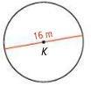

What is the area of a circle with a diameter of 14 ft. in terms of $π$?

Find the area and perimeter of the figure.
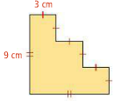

What is the area of the figure?
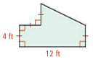
Practice:
Find the perimeter and area of each figure
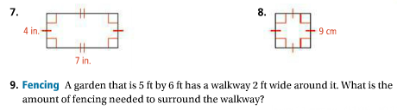

Find the circumference and area of $⨀C$ in terms of $π.$
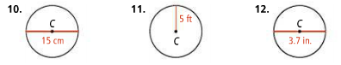

Graph each figure in the coordinate plane. Find each perimeter.

13. X(0, 2), Y(4, -1), Z(-2, -1)
14. L(0, 1), M(3, 5), N(5, 5), P(5, 1

Find the area of the shaded region. All angles are right angles.
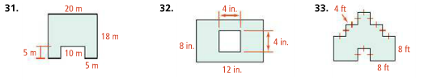

Find the perimeter of each figure.
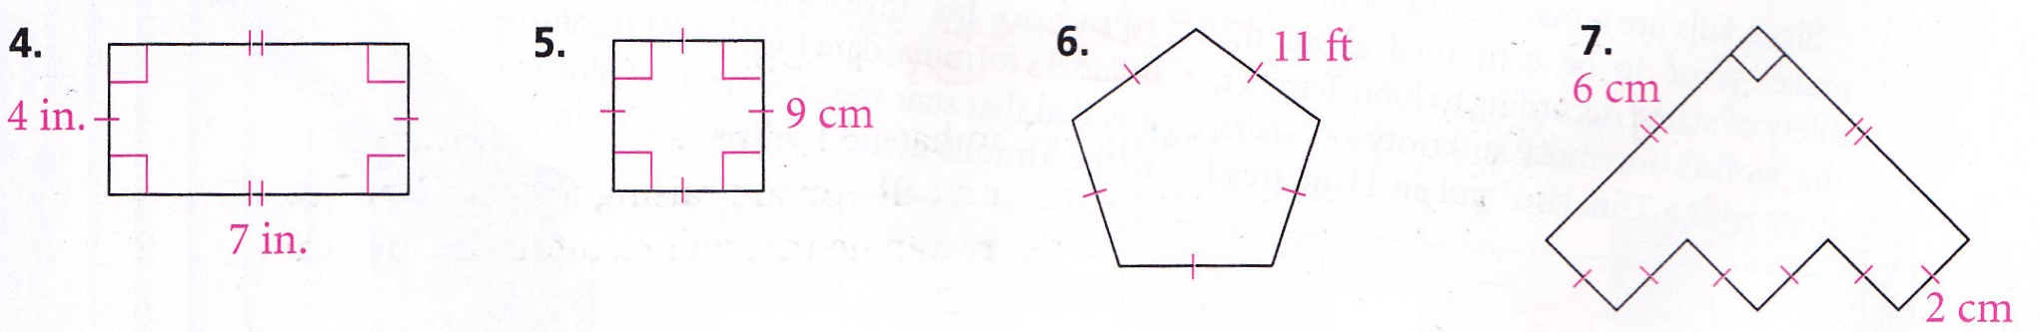

Areas of Parallelograms and Triangles

Warm-Up:
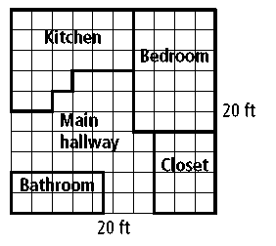
The units of the floor plan at the right are in feet. Find the perimeter and area of each room.
- The kitchen

- The bedroom

- The bathroom

- The closet
What is the area of the main hallway? Explain how you could find this area using the area of each room.

Objectives: 1.

Class Notes:

Area of a Rectangle

Area of a Parallelogram

What is the area?

Area of a Triangle

Find the area
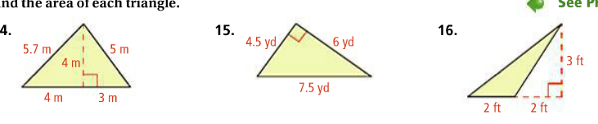
Find the area.
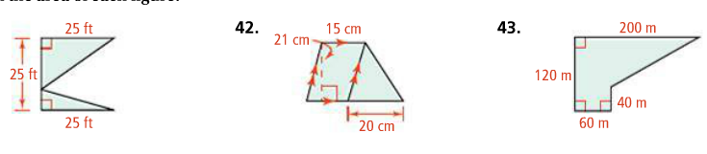

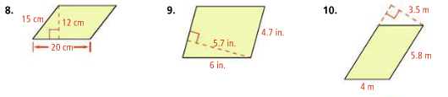

Practice:

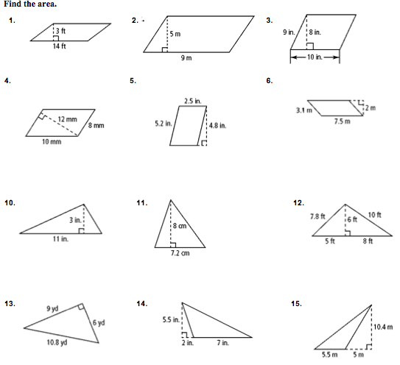

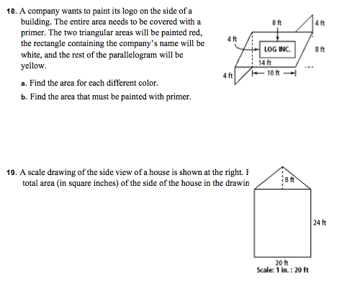
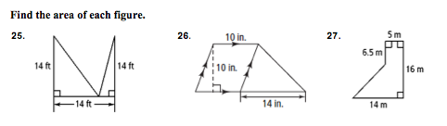

Areas of Trapezoids, Rhombuses, and Kites

Warm-Up:

Find the area.
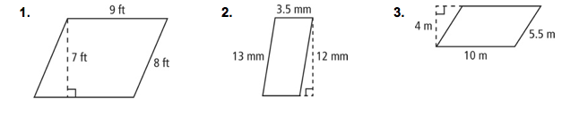
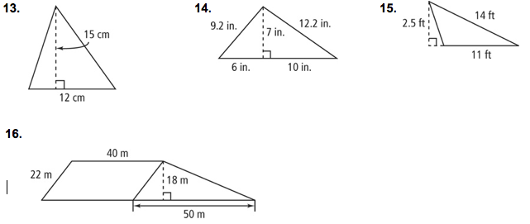

Objectives: 1.

Class Notes:
Area of a Trapezoid
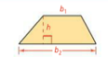

Find the area of each trapezoid.

Find the area of trapezoid PQRS?

Find the area of each trapezoid. If your answer is not an integer, leave it in simplest radical form.

Area of a Rhombus or a Kite
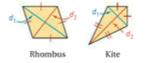
Find the area of kite KLMN?

Find the area of each kite.
Find the area of each rhombus.

Practice:
Find the area of each figure.

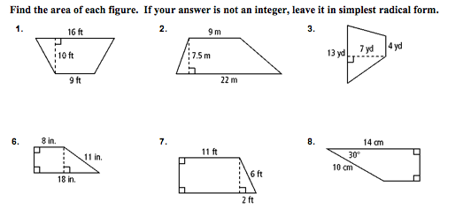
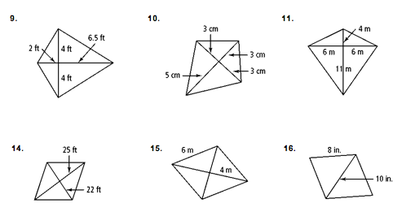

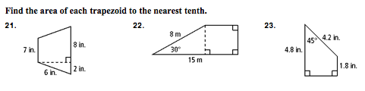

Composite Figures

Warm-Up:

Objectives: 1.

Class Notes:

Find the area of each figure to the nearest tenth.

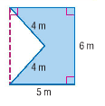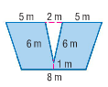

Practice:

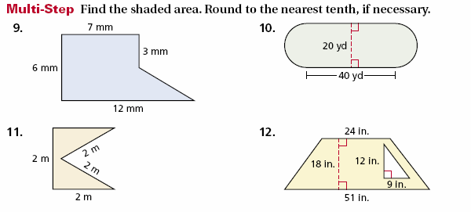

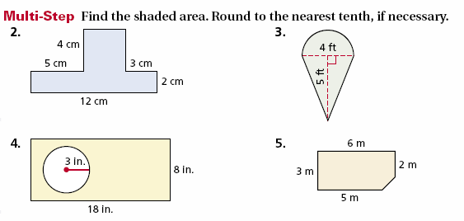

Find the area.

