- The area of a rectangle is 48 square centimeters. The width of the rectangle is 3 centimeters. What is the length of the rectangle?
 | A. | 16 centimeters
 | B. | 21 centimeters
 | C. | 42 centimeters
 | D. | 45 centimeters

- Yoshi is designing a monument that has a triangular base. He drew to represent the base of the monument, as shown in the diagram below.
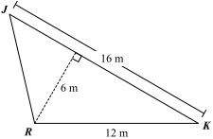
Based on the measurements in the diagram, what is the area, in square meters, of ?

- Four congruent right triangles are cut off the corners of a square. The diagram below shows the dimensions of the square and the congruent right triangles.
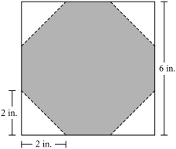

 | A. | 18 sq. in.
 | B. | 20 sq. in.
 | C. | 28 sq. in.
 | D. | 34 sq. in.
What is the area of the shaded part of the diagram?

- The diagram below shows a parallelogram and its dimensions.
 | A. | 30 cm²
 | B. | 36 cm²
 | C. | 60 cm²
 | D. | 72 cm²
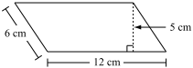
What is the area of the parallelogram?

- The diagram below represents a lawn and its measurements.
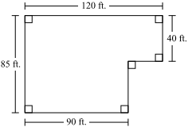
 | A. | 10,200 sq. ft.
 | B. | 8,850 sq. ft.
 | C. | 7,650 sq. ft.
 | D. | 6,600 sq. ft.

What is the area of the lawn?

- A trapezoid has the following dimensions:
- The area is 28 square inches.
- The height is 4 inches.
- The length of one of the bases is 6 inches.
What is the length of the other base?
 | A. | 1 inch
 | B. | 8 inches
 | C. | 16 inches
 | D. | 18 inches

- A park manager is designing four different flower gardens.
- Each garden will have a different shape.
- Each garden will have an area of 64 square feet.
- Draw a sketch of a garden that is shaped like a rectangle and has an area of 64 square feet. Be sure to label all the dimensions needed to determine the area.

- Draw a sketch of a garden that is shaped like a triangle and has an area of 64 square feet. Be sure to label all the dimensions needed to determine the area.

- Draw a sketch of a garden that is shaped like a trapezoid with bases of different lengths and has an area of 64 square feet. Be sure to label all the dimensions needed to determine the area.

- Draw a sketch of a garden that is shaped like a circle and has an approximate area of 64 square feet. Be sure to label all the dimensions needed to determine the area.

- The diagram below shows parallelogram MNPQ and one of its dimensions.
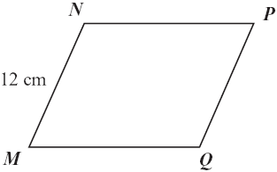
The perimeter of parallelogram MNPQ is 54 centimeters. What is the length, in centimeters, of NP ?

- The diagram below shows the dimensions of a garden.
 | A. | 1200 sq. ft.
 | B. | 1300 sq. ft.
 | C. | 1500 sq. ft.
 | D. | 1800 sq. ft.
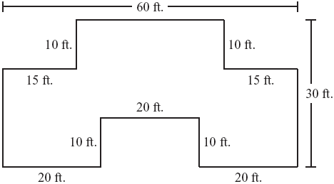
In the diagram, all intersecting line segments intersect at right angles. What is the area of the garden?

- The diagram below shows a triangle and its dimensions. What is the area, in square inches, of the triangle?
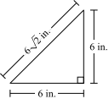
A.
B.
C.
D.

- The diagram below shows a parallelogram and its dimensions.
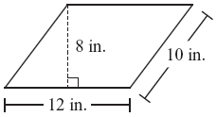
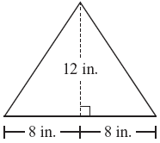
Which of the following has an area equal to the area of the parallelogram?
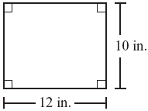 |  | 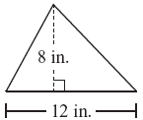  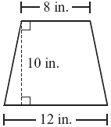

- Rectangle KLMN and its dimensions are shown below. Point P lies on .
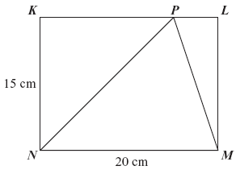
What is the area, in square centimeters, of NPM?

- A parallelogram and its dimensions are shown below. What is the area of the parallelogram?

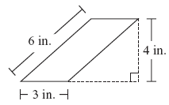
 | A. | 12 sq. in.
 | B. | 13 sq. in.
 | C. | 18 sq. in.
 | D. | 24 sq. in.

- Trapezoid ABCD shown below has bases measuring 6 inches and 10 inches and a height of x inches. Square EFGH shown below has sides measuring x inches. The trapezoid and the square have equal areas.
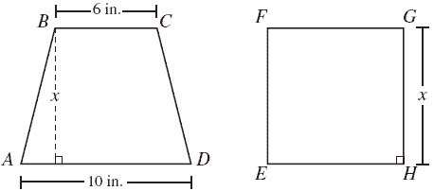
What is the value of x, in inches?

- An international basketball court has a region called the free-throw lane, shown as the shaded part in the diagram below.
- The free-throw lane is shaped like an isosceles trapezoid.
- A semicircle, shown as the unshaded part in the diagram, is attached to the shorter base of the trapezoid.
- The radius of the semicircle is 1.8 meters.
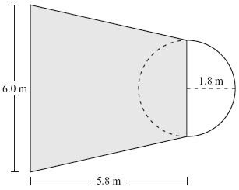
Based on the dimensions in the diagram, what is the area of the shaded free-throw lane?
 | A. | 22.62 square meters
 | B. | 27.84 square meters
 | C. | 34.80 square meters
 | D. | 55.68 square meters

- Manuel is using a small paper rectangle and a large paper rectangle for an art project.
A.
B.
C.
D.
- The length of the small rectangle is half the length of the large rectangle.
- The width of the small rectangle is half the width of the large rectangle.
The area of the small rectangle is how many times the area of the large rectangle?

- A trapezoid and its dimensions are shown below. What is the area of the trapezoid?

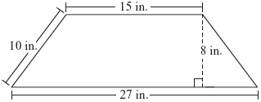
 | A. | 60 sq. in.
 | B. | 168 sq. in.
 | C. | 210 sq. in.
 | D. | 336 sq. in.

- How many square feet of carpeting are needed to cover the floor of the room represented by the drawing below? Note that the shaded region is to be left uncovered to leave space for the construction of a built-in trophy case with a rectangular base.
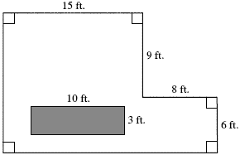
 | A. | 125 sq. ft.
 | B. | 243 sq. ft.
 | C. | 273 sq. ft.
 | D. | 303 sq. ft.

